
Meet Our Trainers Who Care About Getting “IT” Right!
Debbie Hicks
Facilitator

With a comprehensive and varied education background, learning has been at the core of her career. As former President of the Southern Interior Construction Association in BC for 22 years, liaising with the buyers of construction services, architects, engineers and contractors in advocacy and education brings a solid base to her expertise. In addition, her experience as the owner representative for the construction of the new Clubhouse for the Kelowna Yacht Club has provided additional perspective. She has been fortunate to work with the Alberta Construction Association to facilitate industry dialogue on “Optimizing the Flow of Money” and “Non-Standard Contract Clauses and their Costs”. Through these experiences, with a lot of passion and enthusiasm, Debbie is able to bring both knowledge and insight into her work and presentations for the construction industry
n C. Slater, P. Eng., GSC
Bill Chomik, AAA, SAA, OAA, AIBC, FRAIC, RCA
Kasian, Senior Principal, Vice President Institutional

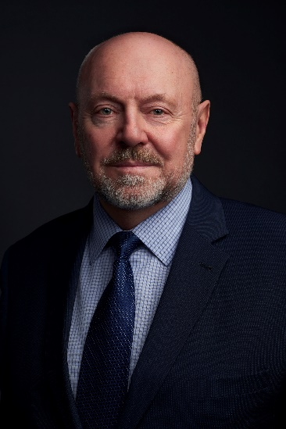
A leading Canadian architect and considered a visionary in his field, Bill has 40 years of experience in architecture, overseeing the design and construction of over 750 buildings worldwide.
Bill’s accomplishments include the University of Calgary’s Taylor Family Digital Library; National Music Centre, Calgary; Calgary Courts Centre; Guangzhou Planetarium, China; Alder Planetarium, Chicago, Illinois; Grande Prairie Library and Art Gallery, Red Deer Performing Arts Centre and Simon Fraser University Trottier Observatory. As a Senior Principal at Kasian, he leads the delivery of architectural, strategic planning (master planning and programming), and interior planning and urban planning services.

Hugh Loughborough, P. Eng., GSC

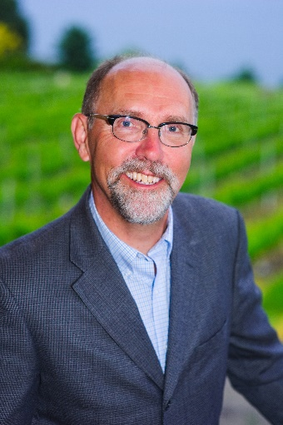
Hugh’s career in the construction industry spans over 40 years. Hugh has held senior management positions related to contracts and risk management.

Hugh earned a B.A.Sc (Civil) in 1980 and a M.A.Sc (Construction Management) in 1986 from the University of Waterloo, is a retired Professional Engineer registered in the Province of Ontario, and is a Gold Seal Project Manager.

Hugh has been actively involved in industry associations over the years, having served as an Executive Member of the Canadian Construction Association, Chairman of CCA’s Standard Practices Committee, CCA’s Trade Contractor Representative to the Canadian Construction Documents Committee and Chair of CCDC’s Insurance and Surety Sub-Committees. He was also President of the Mechanical Contractors Association of Kitchener - Waterloo, a Board Member of the Mechanical Contractors Association of Ontario, and as a National Director of the Mechanical Contractors Association of Canada.

Dean C. Slater, P. Eng., GSC

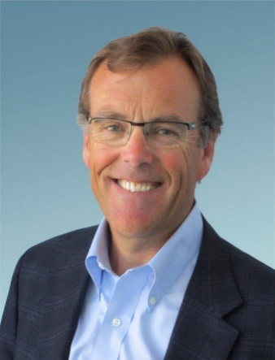
Dean Slater is a Professional Engineer APEGA Life Member with 40 years’ experience in the construction and development industry. He is a Past President of the Calgary Construction Association (CCA) and has held various executive level positions working in General Contracting, Development, and the Alberta Health Services (AHS) project management group.
Dean has worked on many significant projects in Alberta including Calgary’s Petro-Canada (Suncor) Centre, the Olympic Saddledome, the Hyatt Hotel, Telus Convention Centre, SMART Technologies Building, major hospital expansions, and the South Health Campus.

His roles spanned estimating and construction management as both the General Contractor with CANA (Vice-President) and Ledcor Construction, Project Manager on the Smart Technologies Building, and Project Owner’s representative / Vice-President with AHS and Triovest Realty Advisors.

Retiring in January 2018, Dean has embarked on a new role as a fundraising volunteer with Wellspring Calgary – a cancer support group providing programs and education to individuals diagnosed with cancer. Due in part to his volunteer efforts, Dean was recognized in 2018 with CCA’s “Person of the Year” award.

